# **Lab: Routing**

## **Overview**

**Routing is a fundamental mechanic in the overall operations of not only networks but the internet at large. In today’s lab you’ll practice configuring BGP on two routers.**

## **Scenario**

**GlobeX needs to optimize its network traffic with its cloud infrastructure. You’ve been tasked with configuring BGP routing between the on-prem and cloud routers.**

## **Objectives**

* **Download the latest version of Cisco Packet Tracer (link can be found in the resources section below)**
  + **You will need to create an account and enroll in the “Getting Started with Cisco Packet Tracer” course to gain access to the download**
* **In packet tracer, configure BGP between two *2811* model routers**
* **For each router on your network, capture the routing table and configurations of the routing protocols**
* **Update your network topology diagram**

## **Resources**

* [**Cisco Packet Tracer**](https://skillsforall.com/course/getting-started-cisco-packet-tracer)
* [**Packet Tracer - BGP Configuration**](https://www.packettracernetwork.com/tutorials/bgp.html#:~:text=BGP%20in%20Packet%20Tracer,network%20policies%20and%2For%20rulesets.)
* [**Cisco IOS IP Routing: RIP Command Reference**](https://www.cisco.com/c/en/us/td/docs/ios/iproute_rip/command/reference/irr_book/irr_rip.html)
* [**Static Routing Configuration**](https://www.computernetworkingnotes.com/ccna-study-guide/static-routing-configuration-guide-with-examples.html)

## **Tasks**

### **Part 1: Staging**

* **~~Deploy two~~ *~~2811~~* ~~model routers in Packet Tracer~~**

**See diagram right below the instruction’s diagram.**

* + **~~Create a link between the two routers~~**
  + **~~Globex Edge Router~~**
    - **~~Interface FastEthernet0/0: BGP Link with IP address 156.12.1.5/30~~**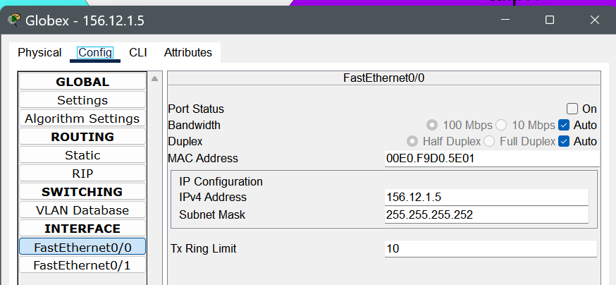
    - **~~Interface FastEthernet0/1: Globex internal network with network address 192.168.100.0/24 and gateway of 192.168.100.1~~**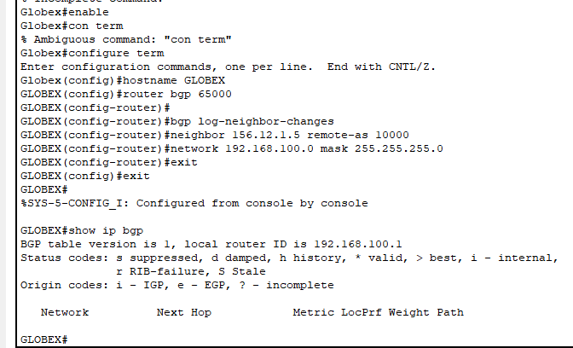
  + **~~Cloud Edge Router~~**
    - **~~Interface FastEthernet0/0: BGP Link with IP address 156.12.1.6/30~~**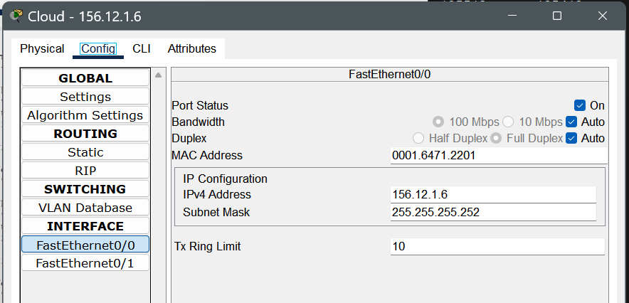
    - **Interface FastEthernet0/1: Cloud hosted network with network address 192.168.200.0/24 and gateway of 192.168.200.1**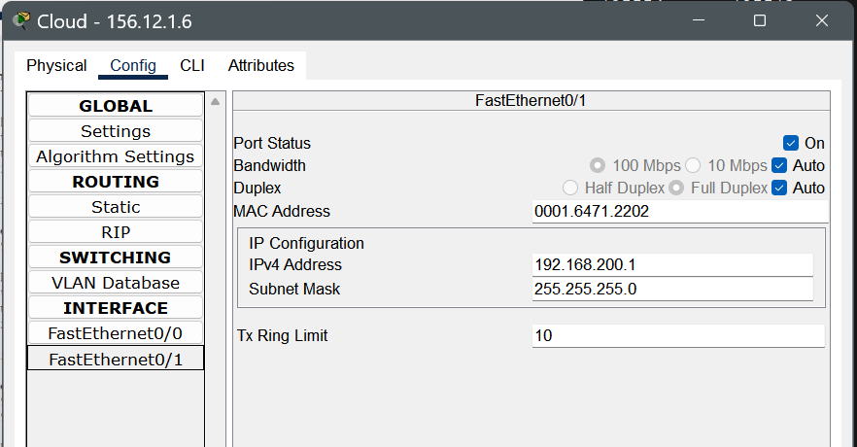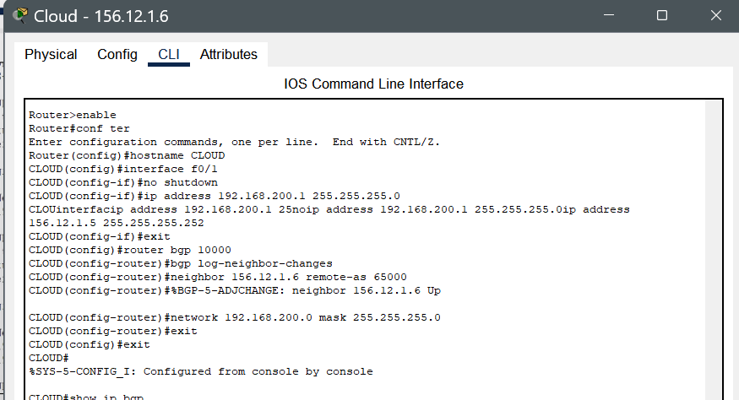

**I know it says the neighbor is 156.12.1.6, I fixed that but forgot to screenshot it, It has been fixed in routing tables and pings.**

* **~~Each network should contain one~~ *~~2960~~* ~~model switch and at least one host~~**
* **~~Here is an example of what the network topology should look like:~~**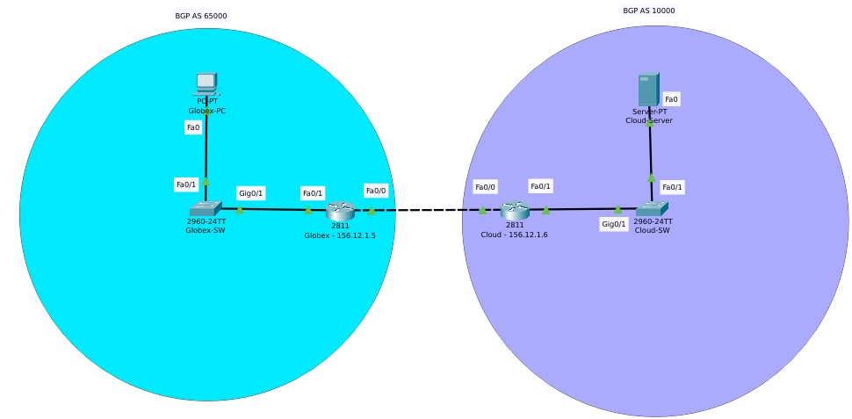
* 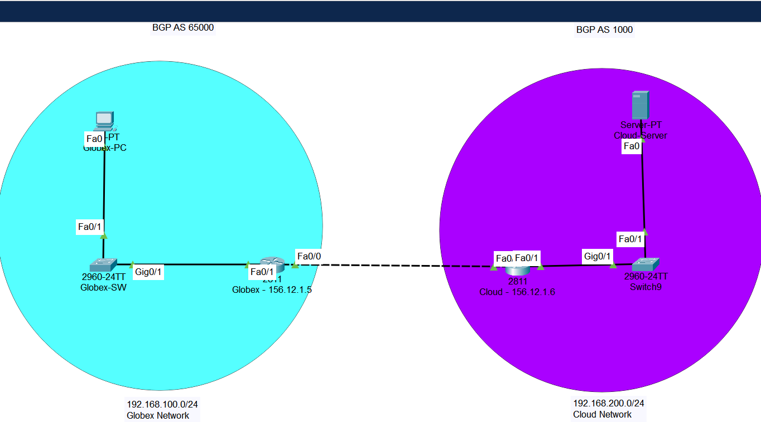

### **Part 2: Configure BGP Routing**

* **~~On the Globex router apply the following settings:~~**
  + **~~Enable BGP~~**
  + **~~Apply the following BGP configuration settings~~**
    - **~~Use private AS values~~**
    - **~~Set cloud router as a BGP neighbor~~**
    - **~~Share the LAN to the neighboring router using BGP~~**
  + **~~Capture screenshots of the data-populated screenshots of the FRR Status page including:~~**
    - **~~BGP Routes~~**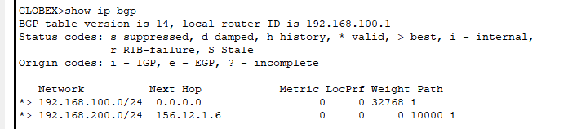
    - **~~BGP Summary~~**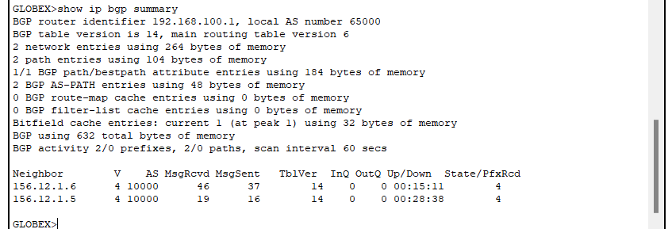
    - **~~BGP Neighbors~~**

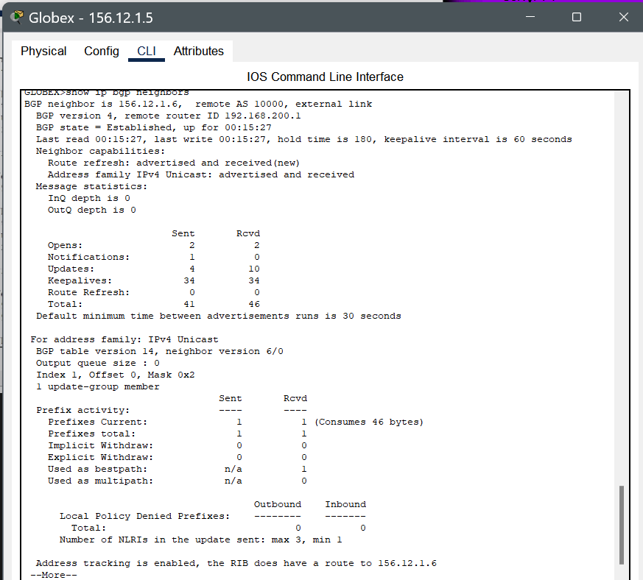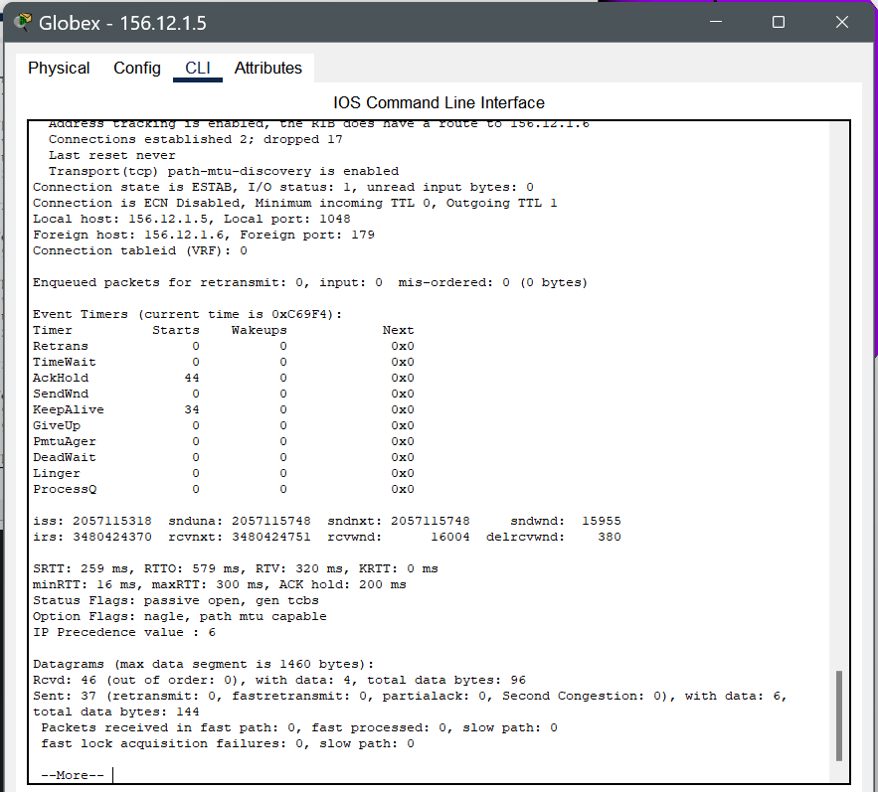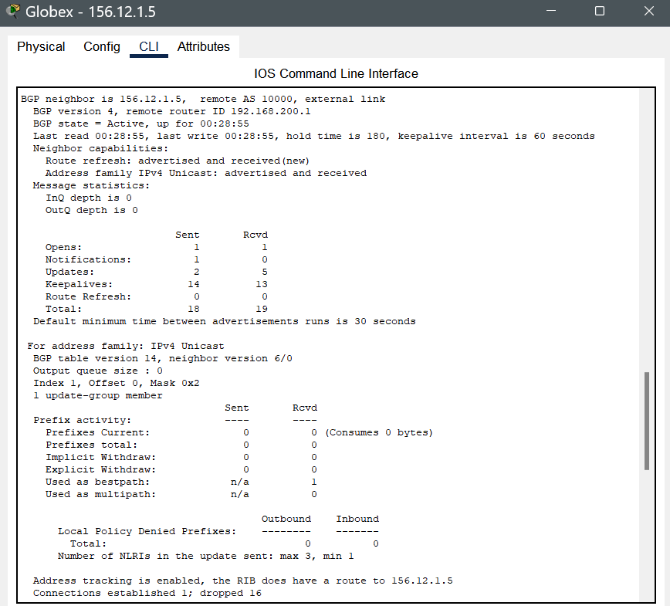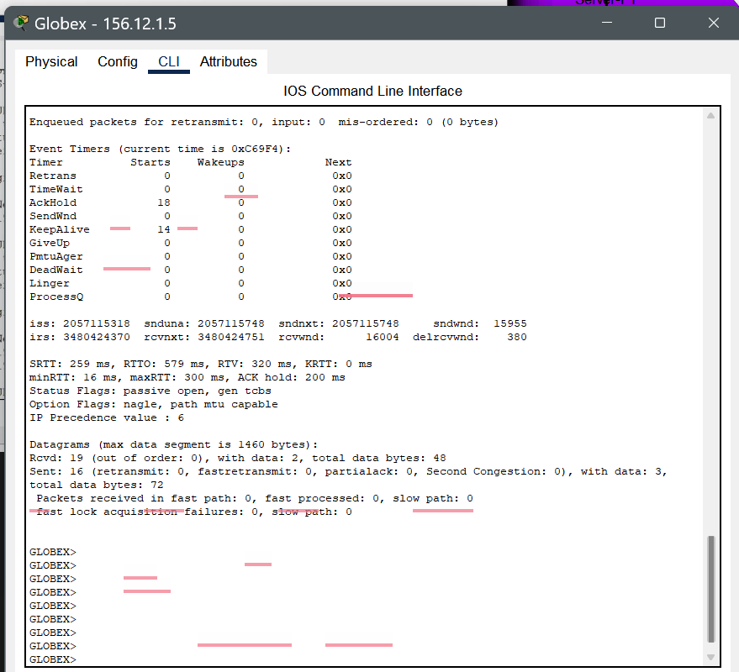

* **~~On the cloud router apply the following settings:~~**
  + **~~Enable BGP~~**
  + **~~Apply the following BGP configuration settings~~**
    - **~~Use private AS values~~**
    - **~~Set Globex router as a BGP neighbor~~**
    - **~~Share the LAN to the neighboring router using BGP~~**
  + **~~Capture screenshots of the data-populated screenshots of the router configurations:~~**
    - **~~BGP Routes~~**

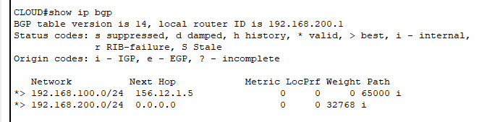

* + - **~~BGP Summary~~**

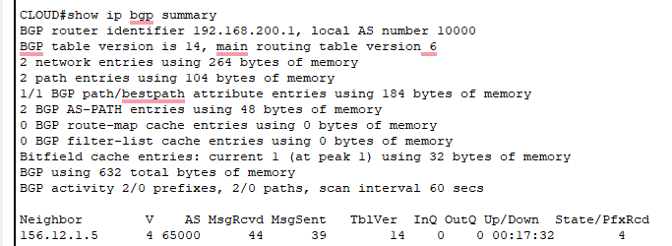

* + - **~~BGP Neighbors~~**

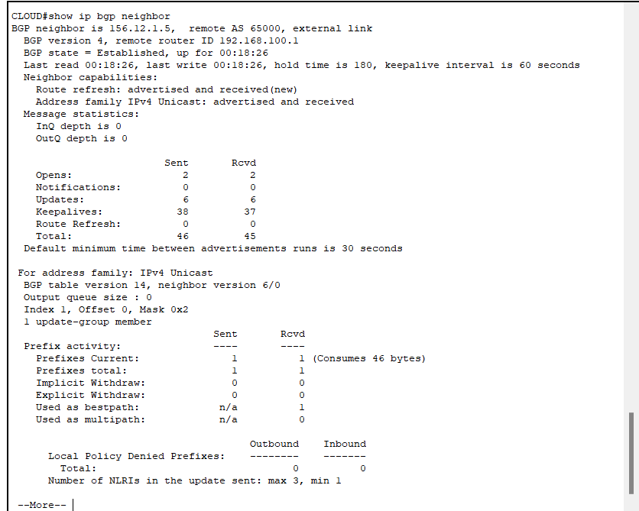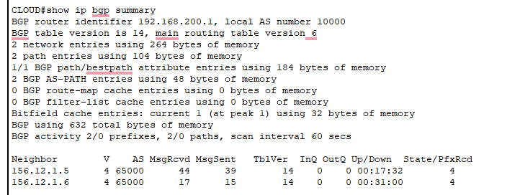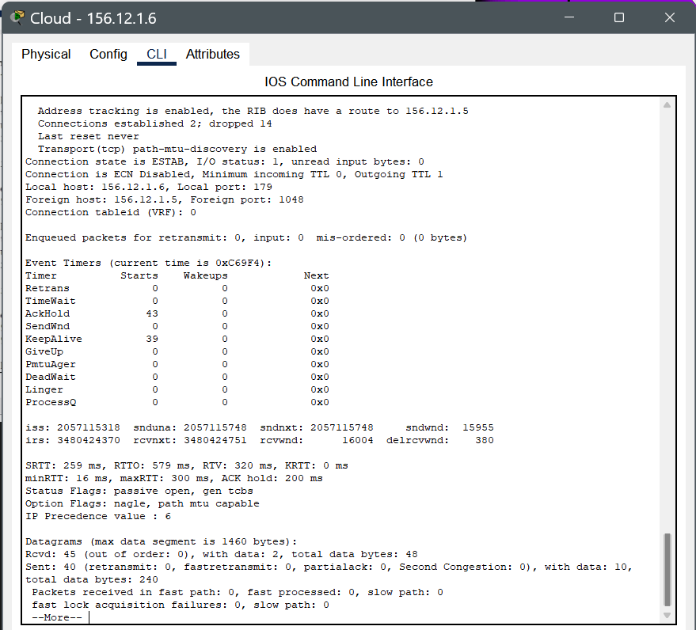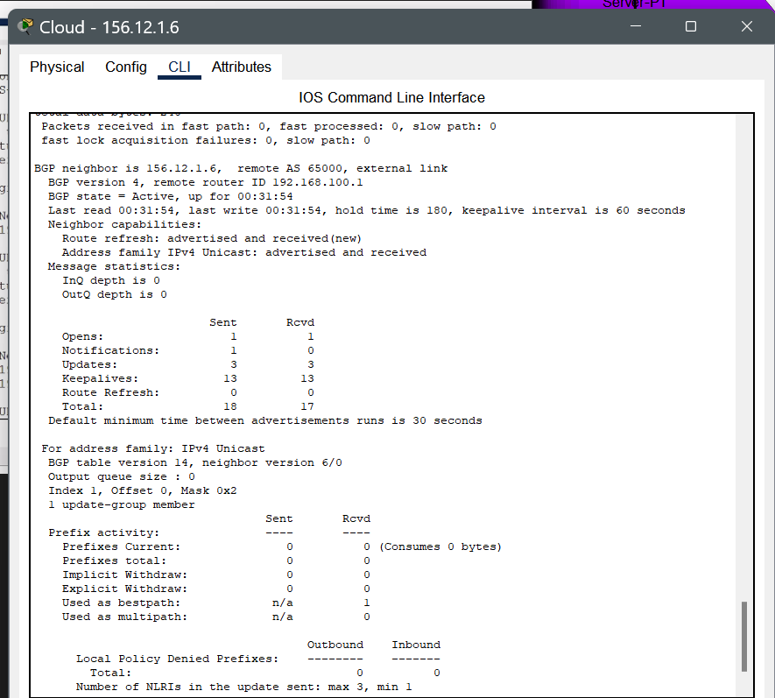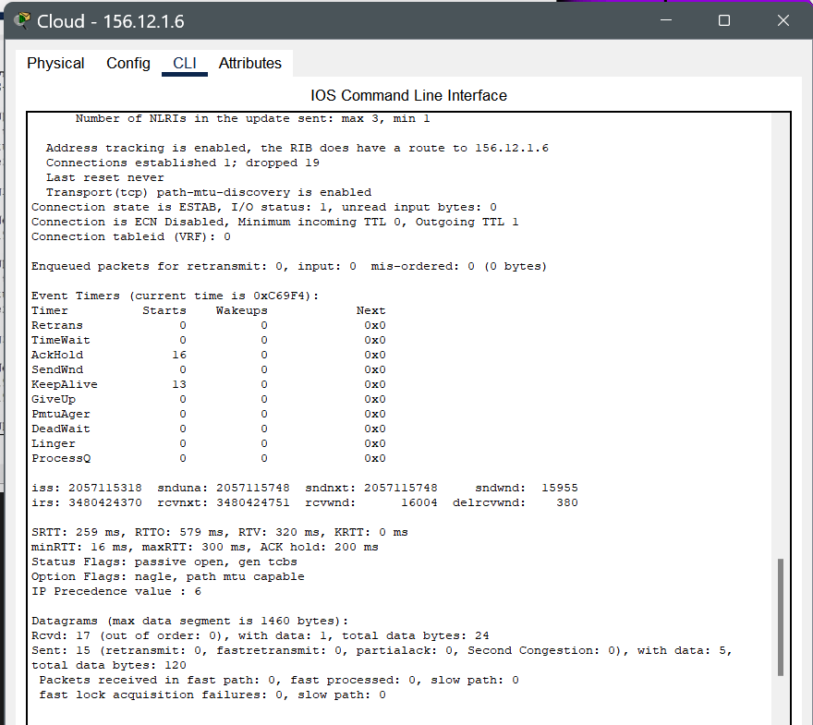

### **Part 3: Routing Tables**

* **~~Locate and capture screenshots of the routing tables for:~~**
  + **~~Globex Router~~**

**Pings and Routing Table**

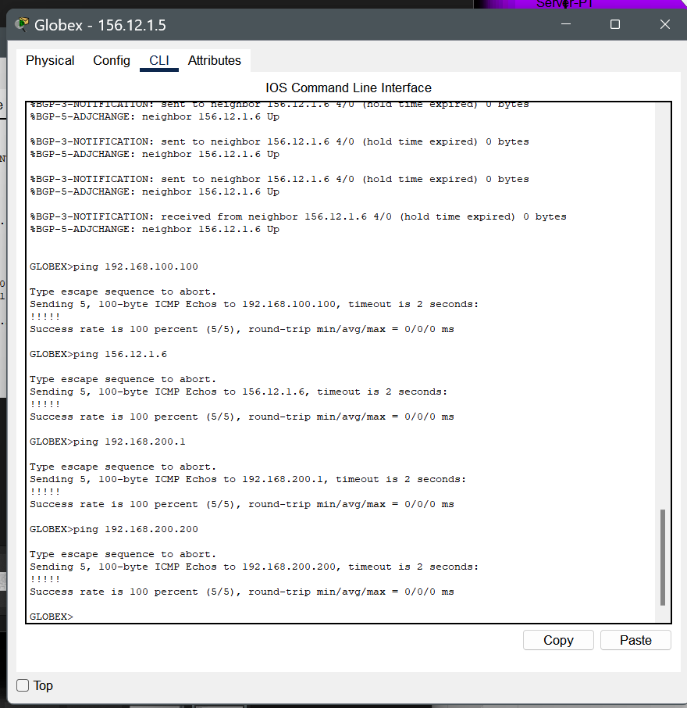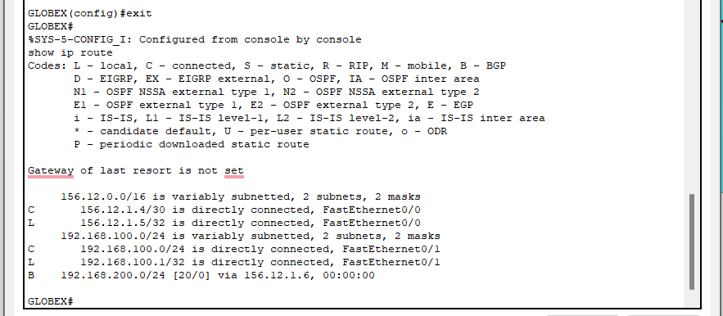

* + **~~Globex PC~~**

**IDK How to get a routing table for a PC, but here are some pings.**

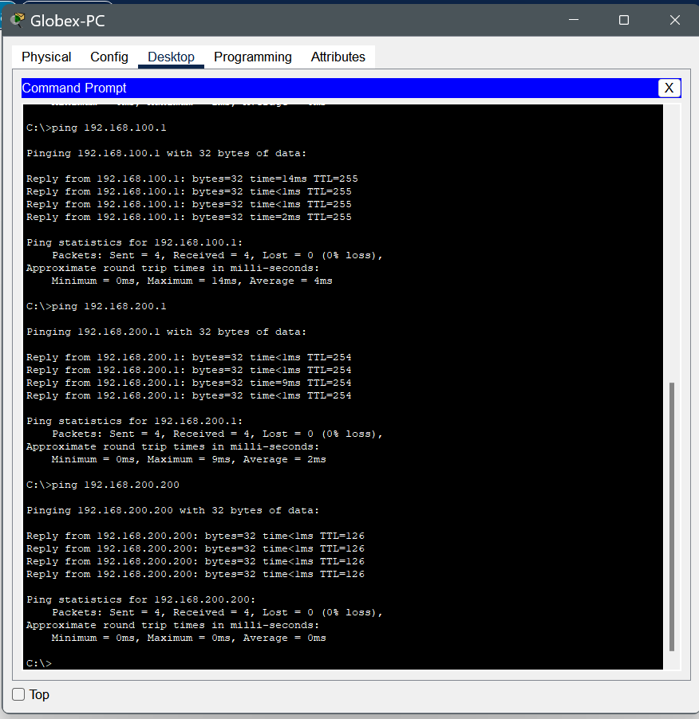

* + **~~Cloud Router~~**

**Pings and Routing Table**

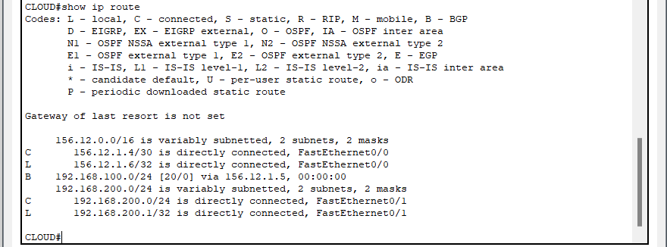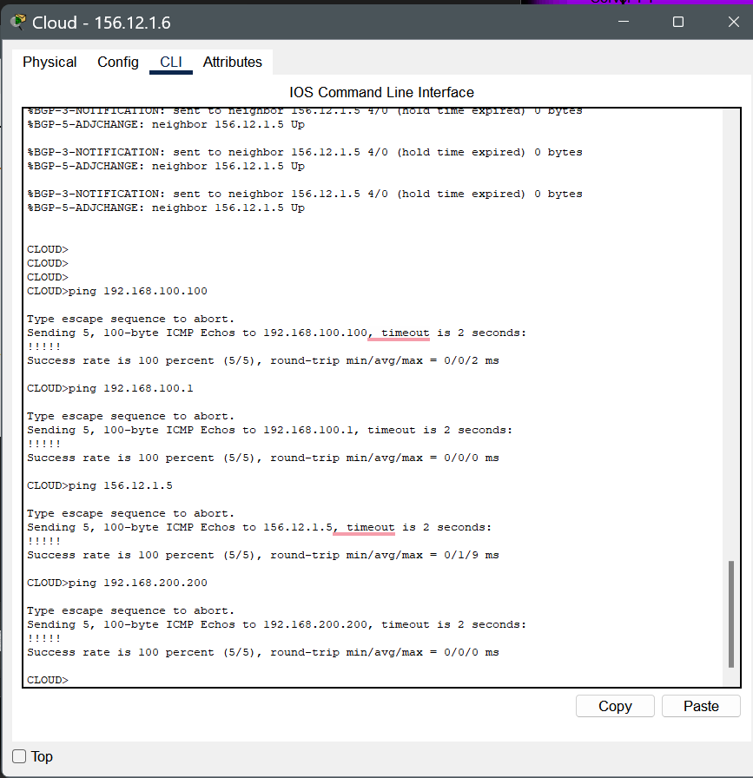

* + **~~Cloud-hosted PC~~**

**IDK How to get a routing table for a PC, but here are some pings.**

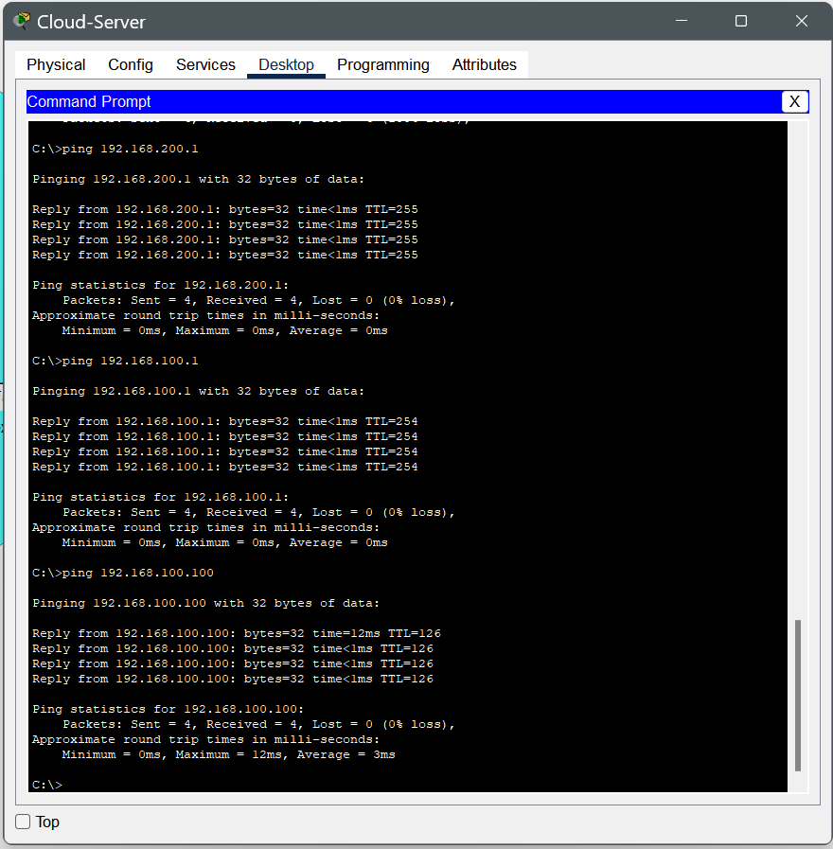

* **Capture screenshots of successful pings from the Globex PC to the cloud-hosted PC. Submit this as part of the assignment.**

